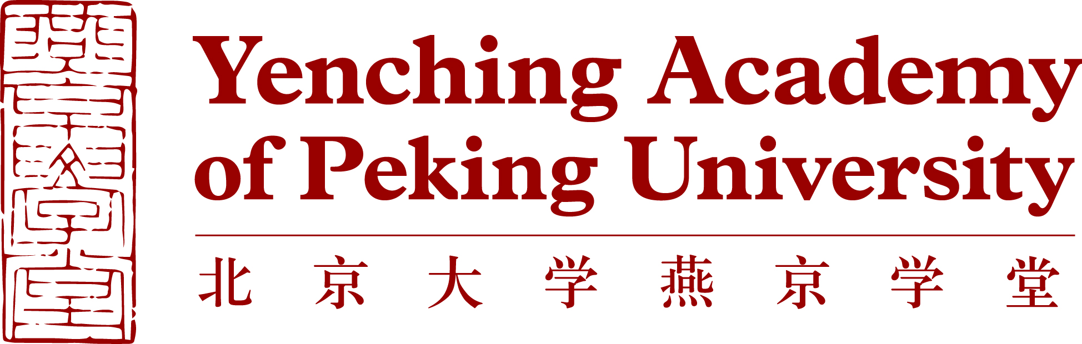

Biographical information
Background Information | Last Name (as shown on passport)
Background Information | First Name (as shown on passport)
Background Information | Middle Name (as shown on passport)
Background Information | Sex
Background Information | Date of Birth (dd/mm/yyyy)
Background Information | Country/Region of Birth
Background Information | Country/Region of Citizenship(s)
Language | Native Language
Language | Other Languages (please specify level of fluency) | Language 1
Language | Other Languages (please specify level of fluency) | Language 2
Language | Other Languages (please specify level of fluency) | Language 3
Correspondence Address | Current Postal Address (where you currently reside)
Correspondence Address | Address
Correspondence Address | City
Correspondence Address | State/Province
Correspondence Address | Zip/Postal Code
Correspondence Address | Country
Correspondence Address | Permanent Mailing Address (if different from current address)
Correspondence Address | Address
Correspondence Address | City
Correspondence Address | State/Province
Correspondence Address | Zip/Postal Code
Correspondence Address | Country
Other Contact Information | Email Address (preferred)
Other Contact Information | Secondary Email Address
Other Contact Information | Skype Username
Other Contact Information | Primary Phone Number
Other Contact Information | Secondary Phone Number

Academic Background
Academic  Background | University
Academic  Background | Location (city, state, country)
Academic  Background | School or Department
Academic  Background | Major
Academic  Background | Second Major (if any)
Academic  Background | Minor (if any)
Academic  Background | Month and Year of Graduation (or expected)
Academic  Background | Degree
Academic  Background | Current GPA (out of 4.0)  If your university uses a different grading system, please indicate the grading scale used and your standing within this scale.
Recommender 1  Peking University only accepts recommendation letters written by full professors or associate professors (or equivalent titles) | Name
 | Institution
 | Job Title
 | Phone Number
 | University Email Address
 | Relationship with the Applicant
Recommender 2  Peking University only accepts recommendation letters written by full professors or associate professors (or equivalent titles) | Name
 | Institution
 | Job Title
 | Phone Number
 | University Email Address
 | Relationship with the Applicant
Study Plan
Item | Details
Degree | Name of Degree | Master’s Program in China Studies
Degree | Preferred Research Area  (Research Area determines the thesis topic and academic advisors, but it does not limit course selection options.) | Please choose one of six concentrations you intend to apply for:  ○China Studies (Economics and Management)  ○China Studies (History and Archaeology)  ○China Studies (Law and Society)  ○China Studies (Literature and Culture)  ○China Studies (Philosophy and Religion)  ○China Studies (Politics and International Relations)
Degree | Year of Entry | September 2024
Language Requirement  (required for those whose first language is not English or have not attended an English-taught degree program) | IELTS (Academic)
 | TOEFL (iBT)
 | Cambridge English Scale (Advanced)
 | • TOEFL and IELTS English proficiency tests must be taken after September 1, 2022. Currently, we do not accept TOEFL MyBest Scores, TOEFL iBT Home Edition, IELTS Indicator test, or IELTS Online.
Chinese Language Level (optional) | HSK Test Level and Score(s)

Personal Statement and Statement of Research Interest

The personal statement, not to exceed 750 words in English, should include a self-introduction and well-articulated explanation of how the candidate would make the most of the Yenching Academy program experience, as well as how it would benefit the candidate’s career. The Statement of Research Interest (maximum 1500 words, excluding citations) should include key research question(s), background to study and/or summary of literature, and study design that could reflect your academic training. Please note that you are not committed to making this proposed project your Master’s thesis topic. The Admissions Committee wants to judge how you formulate and write about academic topics.

Nominees’ online application packages should include the following documents, in English: Personal statement (maximum 750 words); Statement of Research Interest (maximum 1500 words, excluding citations); Curriculum Vitae; official transcript(s); diploma(s) and/or certificate of enrollment; English proficiency score report. Two academic letters of recommendation should be provided by the Partner University to Yenching Academy via email (yca-partnerships@pku.edu.cn).

